**Did Renewable Portfolio Standards Policies in the U.S. cause CO2 Emission Reduction?**

Abhijith Tammanagari, Athena Liu, Tianyun Hou, Weiliang Hu

April 7th, 2022

**Introduction**

Many states in the U.S. discovered the environmental and economic values of renewable resources in comparison to traditional resources such as coal, natural gas, and petroleum starting in the 1990s. To promote domestic energy production and encourage economic development in diversified energy sources, and reduce the emission of greenhouse gasses, Renewable Portfolio Standards policies, which require utilities or other electricity providers to meet a minimum portion of their load with eligible forms of renewable electricity, have been enacted in 29 states and Washington, DC over the years. Some studies and reports found that the RPS policy has been a key driver for the renewable energy boom in the U.S. and also brings potential benefits including reduced emissions, water savings, electricity price stability as well as economic development.[1] While many states are approaching or fulfilling their final statutory targets in the RPS goals, there have been debates on whether these policies should be further expanded based on their associated benefits and costs. Therefore, we would like to focus on the reduction in carbon dioxide emissions as a result of the implementation of state RPS policies to evaluate the causal impact of RPS regulation.

Our main goal is to investigate the causal relationship between RPS and CO2 emissions i.e. we want to determine if the enactment/pressure of an RPS had a significant effect on the change, particularly reduction, in CO2 emissions in the following years after the enactment. The idea behind enacting an RPS is to reduce the global greenhouse gas emission and thus if RPS does play a significant role in these changes then we should promote all states to accept such a policy.

This leads us down the road of performing fixed-effects models between states, with the inclusion of prices of non-renewable energy, GDP as well as weather. Under such setups, we hope to determine how much of the change in CO2 was due to RPS and not other external factors.

Furthermore, some studies also reveal that there exist some regional differences in the RPS role as the policy driver promote renewable energy growth due to the availability of energy resources in different regions or other market-related factors. Therefore, we will conduct a differences-in-differences analysis at the state level to further examine the impact of RPS in terms of reducing CO2 emissions in different regions to develop a more comprehensive and in-depth understanding of the regulation's effectiveness.

**Data**

The most important aspect of our data is going to be the origination dates of RPS policies. Using the image below (from [Berkeley Lab](https://eta-publications.lbl.gov/sites/default/files/rps_status_update-2021_early_release.pdf)), we established which years in which states initially passed their original RPS policies.[2] We decided to prioritize origin years over revisions as they are easier to track than the multiple revision years and multiple varying amendments. Our argument is that the enactment year is most vital as this starts the notion to require the use of more renewable energy sources. This dataset also contains RPS intensity and RPS duration by states. RPS intensity was based on the RPS goal for percentage of renewable resources in energy production. RPS duration was the time gap between RPS expiration year and RPS enactment year. For example, Colorado has RPS intensity of 30 and duration of 16 because their first RPS policy was enacted in 2004, their nearest policy expiration year is 2020, and they aim to have 30% renewable resources for energy production. Since many states could have multiple revisions of RPS policy, we selected the revised policy with the nearest expiration year to 2018.[3] We also found states with expired RPS policies. We removed these states from our analysis because they’re not representative of the treatment group nor the control group.

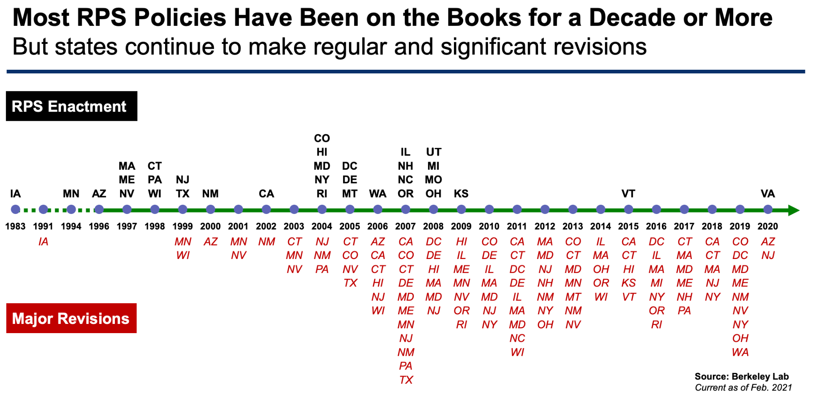

*Figure 1. RPS Enactment and Revision Year for each State[4]*

To determine energy price we utilized the data from the [US Energy and Information](https://www.eia.gov/opendata/qb.php?category=40244) Administration.[5] We made individual calls for coal price, nuclear price (we didn’t use this in our model), petroleum price, and natural gas price for each state and then aggregated that data into one dataframe by year and state. We decided to include this data within our model as this could be a large contributing factor to why less of this source is used resulting in lower CO2 emissions. This dataset ranges from 1970 to 2020. Using the same data source, we also obtained energy generation data for each state. The dataset listed the total amount of energy generated from each energy source between 1990 to 2020. We were able to use this dataset to calculate the percentage of renewable resources used for energy production by states and years. This information would be used for the pressure treatment variable formula in the modeling section.

In order to obtain the weather data which in this case was for average temperature and precipitation, we made API calls to the [National Oceanic and Atmospheric Administration](https://www.ncdc.noaa.gov/cag/statewide/time-series/) and obtained a time series for each state from 1990 to 2020 for precipitation and average temperatures.[6] The weather within a state or region has a large impact on how much energy is consumed and thus could increase or decrease the amount of CO2 produced.

In addition, we obtained the CO2 data from [U.S. Energy Information Administration](https://www.eia.gov/environment/emissions/state/). This dataset contains CO2 emissions measured for each state between 2000 and 2018.[7] Since our goal is to investigate the causal relationship between RPS and CO2 emission, we used this dataset as our target variable in our analysis model.

In order to control the economic activities and their potential influence on CO2 emission, we included GDP into our final dataset. We obtained the GDP data through the [U.S. Department of Commerce - Bureau of Economic Analysis](https://www.bea.gov/).[8] The dataset contains annual industry GDP for all states within the U.S. from 1997 to 2021 recorded in millions of U.S. dollars.

We generated the final dataset by merging the RPS, CO2, GDP, and Weather dataset by year and state. Our final datasets contain CO2 emission as the target variable and RPS Pressure as the treatment variable. Potential control variables for the model include coal price, natural gas price, petroleum price, average temperature, average precipitation, state, year, and GDP. The final dataset contains data between 2000 and 2018. A few states with expired RPS or missing energy prices, weather, CO2 emission, or GDP data were removed to prevent missing data issues.

**Methods & Modeling**

According to Figure 1, between year 2000 and year 2018, many states initiated their RPS policies between 2004 and 2008. As a result, we picked the states in the United States with RPS Enactment in these years as our treated group[9], and the states without RPS enactment before 2018 as our control group.[10]

Since each state enacted RPS policy in different years and adopted different individual goals as well as deadlines that enforces increasing percentage of the electricity consumed in their state must come from renewable resources each year, a binary treatment variable is not the best indicator for accounting those differences in the intensity of the RPS policy across the states. As a result, a pressure variable is created as the final treatment variable to quantify the actual intensity of the RPS policy for each individual state. The formula for calculating the pressure is shown below, where the numerator indicates the gap between the RPS target percentage of renewable resources and current percentage when the RPS is enacted, and the denominator accounts for the time pressure given by the deadline set by each state.

$Pressure = \frac{RPS Target Percent - Percent in Enactment Year}{RPS Target Year - RPS Enactment Year}$

In order to conduct differences-in-differences analysis and build fixed-effects models, it is important to pick the appropriate post-treatment time range. According to multiple research institutions and media disclosures, the economic recession in 2008 generated significant reduction in energy consumption and gas emissions.[11] As a result, we would pick 2010 as our starting point of post-treatment time range, and move all the way to 2018.

Two different fixed-effects models for differences in differences are built to analyze the effects on CO2 emission, one with entity effects for state and time effects for year and the other model with only entity effects for state and no time effects. On one hand, the two-way fixed effects model with both time and state effects eliminate bias from unobservables that change over time but are constant over entities and it controls for factors that differ across entities but are constant over time, which works better in interpreting and estimating the impact of RPS policy in the past. On the other hand, the model with only entity effects eliminates omitted variable bias caused by excluding unobserved variables that evolve over states but are constant across years , which provides better estimations for modeling future impacts of RPS policy.

When diving deeper into our research, it is found that, according to the annual report of RPS status updates from Berkeley Lab, the impact of RPS regulations varies by region. More specifically, RPS demand plays a critical role in driving renewable energy growth in the Northeast and Mid-Atlantic regions, while in regions such as Texas and the Midwest, RPS policy appears to be less important in improving renewable energy usage due to attractive wind energy economics in those regions.[12] To further investigate regional differences in RPS's role in reshaping the energy structure and potentially reducing greenhouse gas emissions, some individual states are selected from different regions across the United States as examples to compare how the causal relationship between RPS and CO2 emission varies across different regions. Furthermore, three other states without RPS regulations are selected as control states for the individual treated state from each region based on similarities in geographical location and energy structure. The groups of control states will average out the idiosyncratic shocks to any individual state and thus provide a more solid comparison between the state with RPS and those without. To visualize the impact of RPS policy across the regions, a differences-in-differences approach is conducted to account for permanent differences between treatment and control states. By comparing the changes in the outcome variable (CO2 emission in million metric tons) over time between the entity that receives treatment and entity that has no treatment, the difference-in-difference approach enables us to remove the baseline differences and exclude other potential confounding variables across the time so that we would be more confident in our causal inferences. By analyzing the difference-in-difference plots, a larger decreasing trend in CO2 emission within a state with RPS in comparison to the decrease in other control states over the same time period would indicate a more significant effect of the policy intervention.

**Results & Analysis**

Summary information of the fixed-effects models are provided in Figure 2 and Figure 3. In the fixed-effects model with both time and entity effects, the only predictor that has a p-value of less than 0.05 is the price of coal, while in the fixed-effects model with only entity effect, average temperature, coal price and GDP all have p-value of less than 0.05. Both of our models below suggest that there is a negative relationship between average temperature and CO2 emissions. We can think of it as: when the temperature gets colder, more energy is used to maintain comfortable conditions within buildings. Our two way fixed-effects model indicates that for each additional degree in temperature the CO2 emissions decrease by .80 Million Metric Tons (mmt). One astonishing finding is that based on our model as coal price increases, the CO2 emissions decrease by -2.14 mmt per each dollar price increase in coal. On the flip side, for natural gas and petroleum prices our model suggests that as prices increase for those non-renewable sources, then so does our CO2 emissions. The coefficient for post-treatment and pressure interaction term is -1.90 with a p-value of .652, which measures the causal effect of RPS policy on CO2 emissions. The p-value suggests there may be some effect of RPS but when generalized across all states the impact is not easily seen. This suggests that we cannot look at states overall but need to look at similar states within a region. According to Figure 3, the one-way fixed-effects model with only state entity effects included provides similar results overall. Generally, average temperature, coal price, and GDP are statistically significant in predicting the emission of CO2.

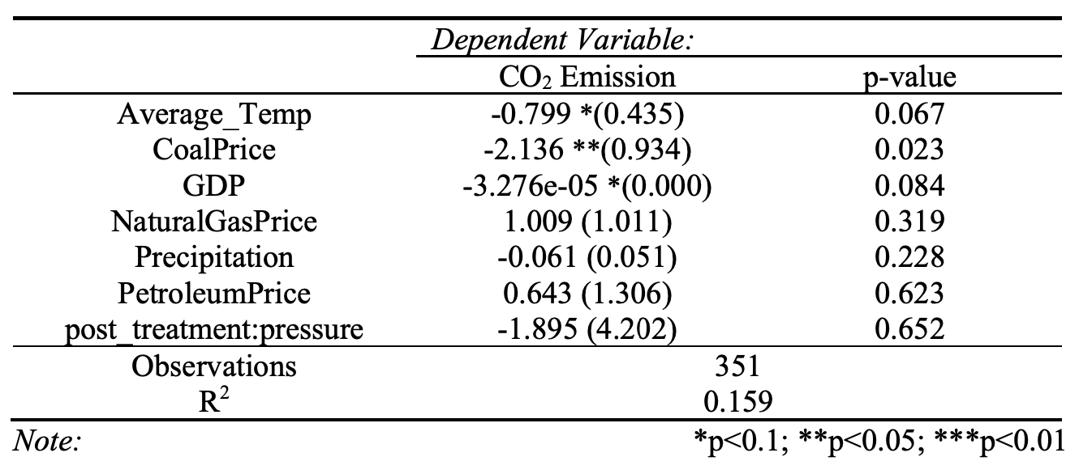

*Figure 2. Two-way PanelOLS Model Result*

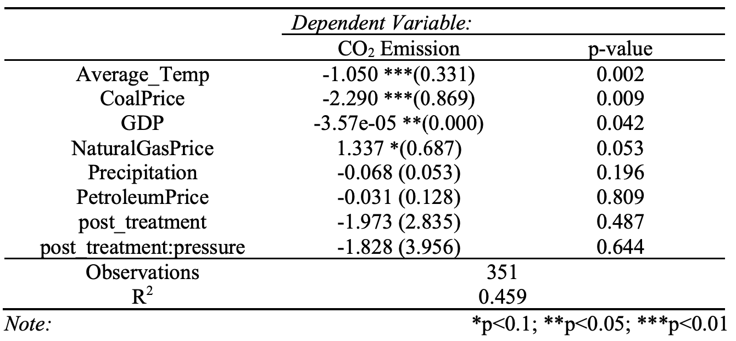

*Figure 3. One-way PanelOLS Model Result*

When diving into regions across the United States and working with a differences-in-differences analysis, the assumption of parallel trends between the treatment and control groups in CO2 emission prior to the policy enactment need to be settled. We plotted the CO2 emission trends before and after treatment (RPS policy enactment), and compared CO2 emissions of treatment and control states from four main energy regions according to Berkeley Lab within the United States -- Mid-Atlantic/Northeast region, the Midwest region, the Southeast region, and the West (Rocky Mountain) region. Some variation in CO2 emission is detected across the regions.[13]

CO2 emissions between the treatment state Illinois, and the control states Arkansas, Louisiana, and Kentucky are compared for the Midwest region. From Figure 4, it can be observed that both the treatment and control states exhibit the close-to-parallel trend of increasing CO2 emissions before the policy intervention. Since the pre-treatment trends are close-to-parallel, we satisfied the assumption for difference-in-difference fixed effects modeling. The trends of CO2 emissions appear to be decreasing for both treatment and control states after six years of RPS enactment, and there’s no significant drop in the overall CO2 emission levels in the treatment state. Thus, it is debatable if RPS is effective in decreasing CO2 emission in this region. As the Berkeley Lab report claims, it is possibly due to the availability of extensive wind resources in the midwest area which constitutes much of the energy consumption in farms and industrial facilities.[14]

A similar analysis for the Mid-Atlantic and Northeast regions is performed. We compared CO2 emissions between the treatment state New York, and the control states West Virginia, Kentucky, and Tennessee. From Figure 5, it can be observed that, while exhibiting mostly parallel trends in CO2 emissions before the RPS enactment, a significant level drop in CO2 emissions can be observed in New York after six years of RPS implementation. For control states, the CO2 emission level only drops slightly over the same time period. The result indicates a relatively effective policy intervention in terms of reducing CO2 emissions in New York state and aligns with the report finding that the RPS role is most critical in the Northeast and Mid-Atlantic region in driving renewable energy growth.

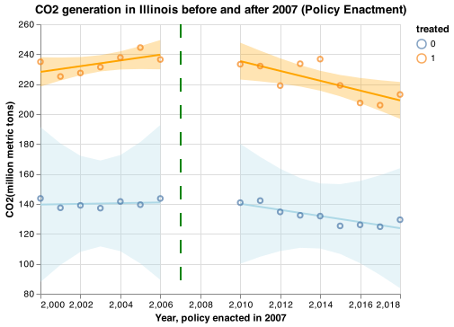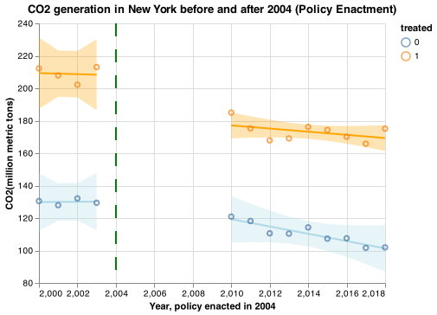

*Figure 4. Midwest Region Figure 5. Mid-Atlantic and Northeast Region*

For the Southeast region, CO2 emissions between the treatment state North Carolina, and the control states Georgia, Florida, and Virginia are compared. Both the treatment and control states display increasing (close-to-parallel) emissions of CO2 before the enactment of RPS. Four years after the enactment, both the treatment and the control states experienced a huge drop in CO2 emissions. After the drop, we could observe that CO2 levels decrease in both treatment and control states. However, it is clear that CO2 decreases much faster in North Carolina than in control states since the orange slope is much steeper (Figure 6). These trends might indicate that RPS is effective in controlling CO2 emissions.

For the Rocky Mountains region, CO2 emissions between the treatment state Utah and the control states Idaho, Wyoming, and Nebraska are compared. Prior to the enactment, both the treatment and control states increasingly emit more CO2 over time. Two years after treatment, both the treatment group and the control group show a decreasing trend in CO2 emissions. However, there is a drastic decrease in CO2 emission level for Utah, but an increase in CO2 emission level for control states. Additionally, the decreasing trend in CO2 emissions in Utah is more significant in comparison to its control states (FIgure 7). This might indicate that RPS is effective in controlling CO2 emissions.

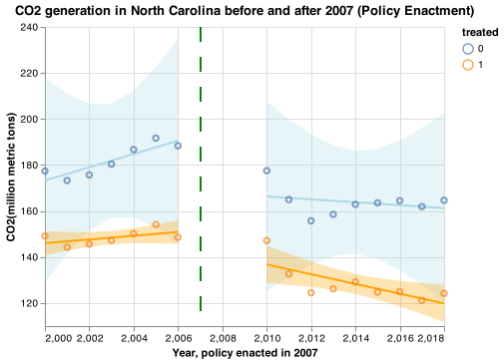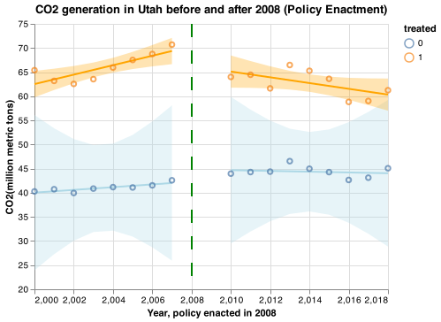

*Figure 6. Southeast Region Figure 7. Rocky Mountains Region*

**Conclusion**

In conclusion, according to thefixed-effects models, there are no clear causal effects of RPS policy on reducing carbon dioxide emissions. However, by further visualizing the trend of CO2 emissions at the state level in different regions, we can observe the regional differences in states’ response to such regulation policies in terms of CO2 emissions. Our results suggest that RPS policy is effectively reducing CO2 emissions in Utah, North Carolina, and New York, while for states such as Illinois, RPS policy appears to play a less important role in reducing emissions. As data scientists, we wouldn’t recommend policymakers simply enact RDS policies in order to achieve emission goals of carbon dioxide reduction.

It is also worth noting that our model suffers from several limitations: RPS policy largely depends on how each individual state defines, structures, and enforces the regulation. The discrepancy in RPS between states made it difficult for us to quantify the overall impact of RPS policy at a national level. Since most states enacted their RPS policies during different years, we were only able to analyze a subset of states that declared RPS between 2004 to 2008. Moreover, each state sets different goals for its RPS and keeps revisioning the goal to expand the timeline of the policy or lift up the target accordingly based on the state’s performance. Penalties for failure to comply with RPS could also vary between states, which could potentially lead to differences in compliance and thus affect the effectiveness of the regulation, making our analysis less generalizable. In addition, there could also exist some spillover effects of the RPS policy on non-RPS states. According to the Berkeley Lab report, RPS policies have spurred some renewable energy growth in states without RPS demand due to extensive trade among states that share the same RTO market or availability of resources in adjacent states.[15] For future researchers, we recommend taking the spillover effect into consideration and avoid making the causal effect of RPS policy on its potential benefits such as CO2 emission reduction to be underestimated.

1. National Conference of State Legislatures. (n.d.). *State Renewable Portfolio Standards and Goals*. State renewable portfolio standards and goals. Retrieved April 7, 2022, from https://www.ncsl.org/research/energy/renewable-portfolio-standards.aspx
2. Barbose, G. (2021, February). *U.S. Renewables Portfolio Standards 2021 Status Update: Early Release*. Energy Technologies Area. Retrieved April 7, 2022, from https://eta-publications.lbl.gov/sites/default/files/rps_status_update-2021_early_release.pdf
3. United State Environmental Protectin Agency. (2015). 2015 Energy and Environment Guide to Action.
4. Barbose, G. (2021, February).
5. U.S. Energy Information Administration (EIA). (n.d.). U.S. Energy Information Administration - EIA - independent statistics and analysis. U.S. Energy Information Administration (EIA). Retrieved April 7, 2022, from https://www.eia.gov/opendata/qb.php?category=40244
6. NOAA National Centers for Environmental information, Climate at a Glance: Statewide Time Series, published March 2022, retrieved on April 7, 2022 from https://www.ncdc.noaa.gov/cag/
7. U.S. Energy Information Administration. (2021b, March 2). Environment. Retrieved April 7, 2022, from https://www.eia.gov/environment/emissions/state/
8. U.S. Department of Commerce. (n.d.). *Bureau of Economic Analysis*. U.S. Bureau of Economic Analysis (BEA). Retrieved April 26, 2022, from https://www.bea.gov/
9. Treatment States: CO,HI,MD,NY,RI,DE,MT,WA,IL,NH,NC,OR,MI,MO,OH
10. Control States: AK,AR,FL,GA,ID,KY,LA,MS,NE,TN,UT,VA,WV,WY
11. Rohekar, J. (2015, July 25). Recession, not natural gas, was major cause of drop in US emissions. DownToEarth. Retrieved April 7, 2022, from https://www.downtoearth.org.in/news/climate-change/recession-not-natural-gas-was-major-cause-of-drop-in-us-emissions-50594
12. Barbose, G. (2021, February).
13. Barbose, G. (2021, February).
14. Barbose, G. (2021, February).
15. Barbose, G. (2021, February).